문제.

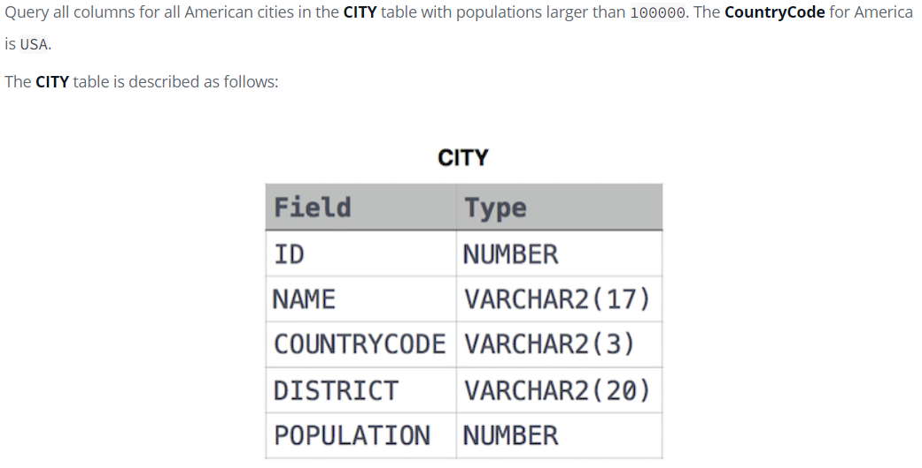

해답

SELECT \*

FROM CITY

WHERE

COUNTRYCODE = "USA"

AND POPULATION > 100000;

문제.

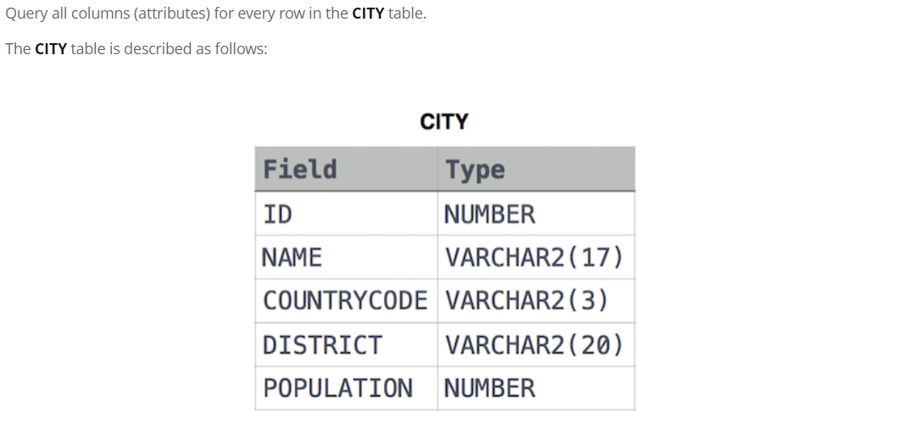

해답

SELECT \*

FROM CITY

문제

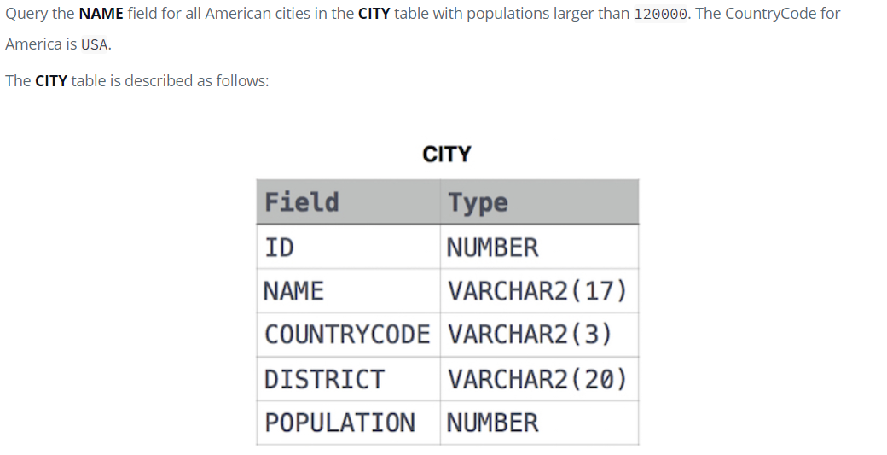

해답

SELECT NAME

FROM CITY

WHERE POPULATION > 120000 AND

COUNTRYCODE = "USA"

문제

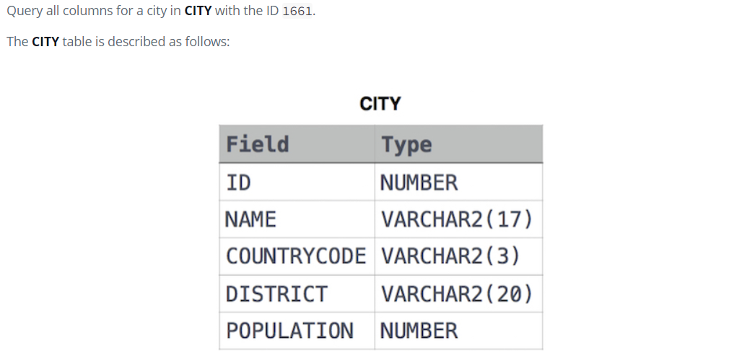

해답

SELECT \*

FROM CITY

WHERE ID = 1661

문제

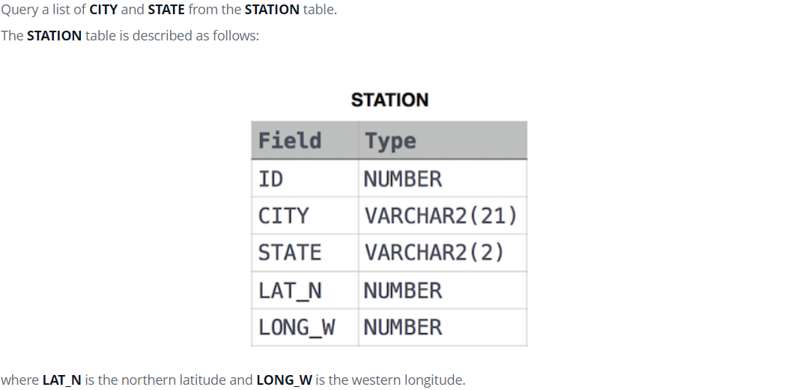

해답

SELECT CITY, STATE FROM STATION